MENU DINAMICO NO WORDPRESS

https://www.youtube.com/watch?v=gD5OdlM88Nc

* Inserir o arquivo na mesma pasta de index.php



index

<link rel="stylesheet" href="<?php bloginfo('template_url'); ?>/css/bootstrap.css">

* No arquivos functions.php insira o código

<?php

// REGISTRA O CUSTOM NAVIGATION WALKER

require_once get_template_directory() . '/class-wp-bootstrap-navwalker.php';

// REGISTRAR OS MENUS

register_nav_menus( array(

'principal'=>__('Menu Principal','thema')

));

* No painel do wordpress aparecerá a opção menu

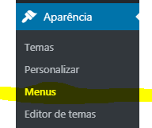

* Adicione o nome do menu

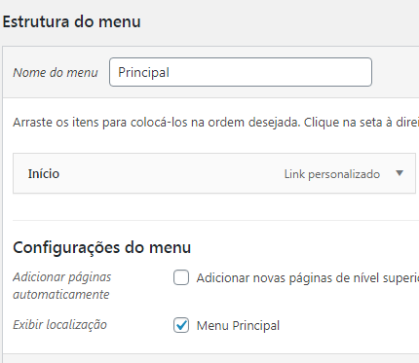

* 

PAGINA NO MENU

* Cria uma pagina com qualquer nome ex: page-nosidebar.php
* Cria a estrutura e no top digite



* Criar uma nova pagina no wordpress e relaciona ao modelo “sem barra lateral”

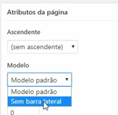

* Acrescenta a pagina no menu

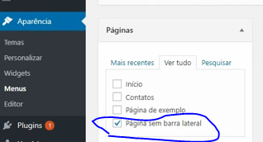

INSERIR E SUBSTITUIR AS CLASSES

<div class="container">

<div class="row">

<div class="col">

<nav class="navbar navbar-expand-lg navbar-dark bg-primary " role="navigation">

<div class="container">

<a class="navbar-brand" href="#" data-toggle="collapse" data-target="#bs-example-navbar-collapse-1" aria-controls="bs-example-navbar-collapse-1" aria-expanded="false" aria-label="Toggle navigation">Menu</a>

<button class="navbar-toggler" type="button" data-toggle="collapse" data-target="#bs-example-navbar-collapse-1" aria-controls="bs-example-navbar-collapse-1" aria-expanded="false" aria-label="Toggle navigation">

<span class="navbar-toggler-icon"></span>

</button>

<?php

wp_nav_menu( array(

'theme_location' => 'principal',

'depth' => 2,

'container' => 'div',

'container_class' => 'collapse navbar-collapse',

'container_id' => 'bs-example-navbar-collapse-1',

'menu_class' => 'nav navbar-nav collapse navbar-collapse d-flex flex-wrap justify-content-between',

'fallback_cb' => 'WP_Bootstrap_Navwalker::fallback',

'walker' => new WP_Bootstrap_Navwalker(),

) );

?>

</div>

</nav>

</div>

</div>

</div>

<script src="https://ajax.googleapis.com/ajax/libs/jquery/3.3.1/jquery.min.js"></script>

<script src="<?php bloginfo('template_url') ?>/js/popper.js"></script>

<script src="<?php bloginfo('template_url') ?>/js/bootstrap.js"></script>